Assignment 5
Relational and Logical Operators
- Write a query that will give you all orders for more than Rs. 1,000.
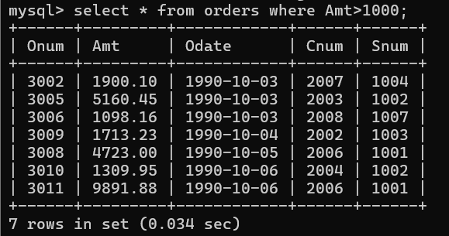
- Write a query that will give you the names and cities of all salespeople in London with a commission above 0.10.
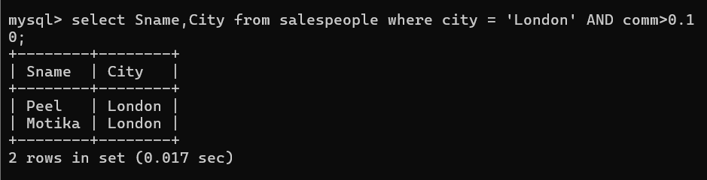

- Write a query on the Customers table whose output will exclude all customers with a rating ≤ 100, unless they are located in Rome.
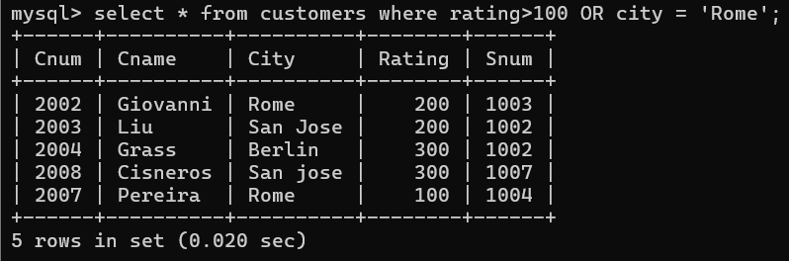

- What will be the output from the following query:
Select * from Orders
where (amt < 1000 OR
NOT (odate = ‘1990-10-03’ AND cnum > 2003));
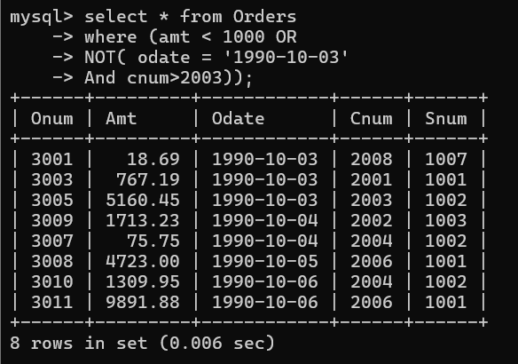
- What will be the output of the following query:
Select * from Orders
where NOT ((odate = ‘1990-10-03’ OR snum > 1006) AND amt >= 1500);
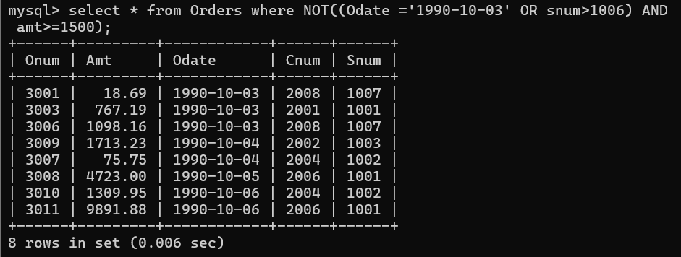
- What is a simpler way to write this query:
Select snum, sname, city, comm From Salespeople
where (comm > .12 OR comm < .14);
